



CASE MANAGEMENT SYSTEM AND INVESTIGATION
USER MANUAL

Version 1.0
03.06.2026
Document Information
Project | TAZAMA FRAUD MANAGEMENT SYSTEM
Document Title | CASE MANAGEMENT SYSTEM AND INVESTIGATION
Prepared by | UME SAUDA GHANYANI – SENIOR BA @ PAYSYSLABS
Version Number | 1.0
Version Date | 03.06.2026

Document Revision History
Date | Author | Version | Change Reference
03.06.2026 | UME SAUDA GHANYANI | 1.0 | BASELINE VERSION SHARED WITH TAZAMA FOR REVIEW

Table of Contents
1. Introduction 6
1.1 Purpose of the CMS and Investigation Module 6
1.2 Scope of the User Manual 7
2. System Overview 7
2.1 CMS Key Components and Modules 7
2.1.1 Case Creation and Alert Generation 8
2.1.2 Case Investigation 9
2.1.3 Case Closure and Approval 10
2.1.4 Reporting and Auditing 10
2.2 Roles and Permissions 11
3. Getting Started 12
3.1 System Requirements 13
Technical Requirements 13
User Account Requirements 13
System Dependencies 13
3.2 User Login and Access 13
Login Procedure 13
Authentication Controls 13
Access Control Principles 13
3.3 Navigating the Dashboard 14
Dashboard Components 14
Left Navigation Panel 15
3.4 User Roles: Investigator, Supervisor, Compliance Officer 15
Investigator 15
Supervisor 15
Compliance Officer 16
4. Case Management 16
4.1 End to End Case Management Workflow 17
4.2 Case Creation 17
4.2.1 Manual Case Creation 17
4.2.2 Automatic Case Creation (Alert Triage Module) 25
4.3 Task Assignment and Re-assignment 29
4.3.1 Assigning Task to Investigators 29
4.3.2 Re-assigning Tasks 31
4.3.3 Unassigning a Task 33
5. Investigation Process 36
5.1 Initiating an Investigation 36
A. Marking the Task as In Progress 36
B. Opening the Investigation Workspace 36
5.2 Evidence Collection and Documentation 37
5.2.1 Linked Items (Transaction History) 37
5.2.2 Evidence Upload (Evidence Tab) 37
5.3 Conducting the Investigation (Visualization) 38
5.4 Case Notes and Remarks 38
A. Recording Investigation Notes 38
B. Reviewing Investigation Summary 39
5.5 Completing the Investigation Task 40
A. Confirming Completion 40
5.6 Investigation Lifecycle Summary 41
6. Suspend and Resume a Case 41
6.1 Suspending a Case 41
6.2 Resuming a Case 42
7. Case Closure and Approval 43
7.1 Case Closure Process (Investigator Action) 43
A. Initiating Case Closure 43
B. Complete Case Investigation Popup 43
C. System Behavior After Submission 44
7.2 Auto Case Closure 45
7.3 Final Outcome Selection 45
7.3.1 Closed Refuted (81) 45
7.3.2 Closed Confirmed (82) 45
7.3.3 Closed Inconclusive (83) 45
7.4 Supervisory Approval 46
A. Supervisor Initiates Review 46
B. Case Closure Review Popup 46
C. Generating Investigation Report 46
D. Finalizing and Approving the Report 47
E. If Supervisor Rejects Case Closure 48
7.5 Post-Closure Actions 49
7.6 Complete Case Lifecycle Overview 49
8. Audit and Compliance Features 49
8.1 Comments History and Case History 49
A. Case History (System-Level Timeline) 49
B. Comments History (User-Level Audit Trail) 50
8.2 Compliance Workflow 51
A. Visibility Restrictions 51
B. Investigation Report Access 51
C. SAR/STR Task Generation 52
8.3 Regulatory Reporting (SAR/STR Filing Process) 53
A. Assigning SAR/STR Task 53
B. Mark Task In Progress 53
C. Open SAR/STR Filing Popup 53
D. Mark SAR/STR Task Complete 54
C. Status Code Enforcement 54
8.4 End-to-End Compliance Lifecycle 55
9. Appendices 56
9.1 Glossary of Terms 56

sss

Introduction

Purpose of the CMS and Investigation Module
The Case Management System (CMS) and Investigation Module within the Tazama ecosystem are designed to provide a streamlined, efficient, and compliant approach to managing fraud detection and compliance investigations. The primary purpose of these modules is to centralize and automate the handling of cases flagged for review due to suspicious activities such as fraud or money laundering. By integrating all case management and investigative processes into a single platform, CMS ensures greater transparency, consistency, and accountability throughout the lifecycle of an investigation.
Key objectives of the CMS and Investigation Module include:
- Automating case creation from alerts or manual inputs to reduce human error and improve response time.
- Providing structured workflows to ensure each case follows a standardized process, from triage and investigation to closure and reporting.
- Ensuring compliance with regulatory requirements such as Anti-Money Laundering (AML), Counter-Terrorism Financing (CTF), and other relevant laws.
- Enhancing collaboration among investigators, supervisors, and compliance officers to ensure that cases are handled effectively and efficiently.

Scope of the User Manual
This user manual provides comprehensive guidance for users of the Tazama Case Management System (CMS) and Investigation Module. It is designed to help users understand the full range of system functionalities, from creating and managing cases to reporting and audit features. The manual covers the roles and responsibilities of different users, case creation, investigation workflows, case closure, compliance reporting, and system troubleshooting.
The scope of this manual includes:
- System setup and configuration to ensure optimal usage.
- Detailed walkthroughs of the case management process, from the creation of alerts to case closure.
- Investigation processes include evidence collection, task management, and report generation.
- Audit and compliance features to ensure data integrity and regulatory compliance.
- Troubleshooting and support to address common issues users may encounter while using the system.
This manual is intended for a variety of users, including investigators, supervisors, and compliance officers. It serves as both a reference guide and a step-by-step instructional resource.

System Overview

CMS Key Components and Modules
The Case Management System (CMS) consists of several key components and modules, each serving a specific function to ensure the efficient handling of cases from alert generation to closure. These include:

Case Creation and Alert Generation
Case Creation and Alert Generation is the foundational component of the CMS, where the investigation process begins. The system can either create cases automatically from alerts or allow users to manually create cases based on external inputs.
- Alert Generation Process:
  - Alerts are generated when:
    - Suspicious transactions are detected (e.g., large transfers, cross-border payments).
    - A pattern of behavior that violates compliance rules is identified.
  - Alerts are ingested into the system via REST APIs or NATS (message queue), ensuring real-time processing.
  - The alert includes relevant data like the transaction ID, alert type (AML, fraud), priority level, and alert status.
- Case Creation Process:
  - Automatic Case Creation: When an alert is received, the CMS can automatically create a case by associating the alert with a case type (Fraud, AML) and priority level (High, Medium, Low). The system uses configurable thresholds to determine when a case should be auto-created based on alert confidence levels.
  - Manual Case Creation: In some instances, a user (e.g., Supervisor or Investigator) may manually create a case if an alert does not meet the criteria for automatic generation or if there is a need to investigate an issue outside of the automated process. Users input necessary details, such as alert type, priority, case description, and reason for investigation.
- Alert Classification and Prioritization:
  - Once the case is created, the system classifies and prioritizes alerts based on configurable rules, such as transaction value, geographic risk, and historical patterns of suspicious activity.
  - Each case is assigned a case ID, which is used throughout the case lifecycle to track progress and actions taken.
  - Alerts can be closed automatically if the system determines they do not meet the threshold for further investigation, or manual intervention may be required to resolve the case.
- Alert Dashboard:
  - The Alert Dashboard provides a comprehensive overview of all incoming alerts, allowing users to quickly view and manage the alerts. The dashboard displays key information such as the alert type, priority, assigned investigator, and case status.
  - Alerts can be filtered based on specific criteria like alert type (AML, fraud), priority, or status (open, resolved).

Case Investigation
The Case Investigation module is the heart of the CMS, where the actual review and analysis of flagged transactions occur. This module ensures that cases are investigated thoroughly and efficiently.
- Investigation Workflow:
  - The investigation process starts once a case has been created and assigned to an investigator. The investigator is responsible for gathering evidence, performing analysis, and determining the validity of the alert.
  - Investigator Actions:
    - Case Review: Investigators begin by reviewing case details, including the alert, the flagged transaction, and any supporting evidence available.
    - Evidence Collection: Investigators gather evidence, such as KYC (Know Your Customer) data, FIU (Financial Intelligence Unit) reports, Sanctions List checks, and transaction history to support or refute the alert.
    - Analysis: Investigators analyze transaction patterns, behavior, and risk factors to determine whether the flagged activity is suspicious.
    - Investigation Status: The investigator updates the case status (e.g., In Progress, Complete) and adds relevant case notes or comments to document the investigation.
- Case Task Management:
  - The system enables investigators to break down the investigation into smaller tasks, which can be assigned to themselves or other users.
  - Tasks can include actions such as evidence verification, KYC checks, transaction history review, or risk assessment.
  - Task progress is tracked, and cases cannot be closed until all tasks are marked as Complete.

Case Closure and Approval
Once an investigation is complete, the Case Closure and Approval module ensures that the case is properly closed, with all findings documented and approved by relevant stakeholders.
- Case Closure Process:
  - After the investigation, the investigator submits the case for closure, including a final report that summarizes the findings, evidence, and the investigator’s recommendations (e.g., Confirmed Fraud, Refuted Fraud, Inconclusive).
  - Supervisor Approval: The case is reviewed by a supervisor, who can approve the case closure or send it back for further investigation.
  - Final Outcome: The supervisor selects the final outcome from a list of options, such as:
    - Closed Refuted: The investigation found no evidence of fraud or suspicious activity.
    - Closed Confirmed: The investigation confirmed fraudulent or suspicious activity.
    - Closed Inconclusive: The investigation was unable to determine if the activity was fraudulent or suspicious due to insufficient evidence.

- Audit and Compliance Logging:
  - The system automatically logs all actions taken during the closure process, including case reviews, supervisor approvals, and final decisions. This ensures regulatory compliance and provides a complete audit trail.

Reporting and Auditing
The Reporting and Auditing module in CMS enables users to generate comprehensive reports and ensures compliance with internal and external regulations.
Dashboards
- Users can access dashboards that display case statuses, investigation progress, case workload, and KPI tracking.
Reports
- CMS supports the generation of detailed reports on case histories, including investigation findings, case closure outcomes, and audit logs. These reports can be used for internal reviews and external regulatory reporting.
Audit Logs
- The CMS maintains a comprehensive audit log that tracks every action taken on a case, including user activities (e.g., case creation, task updates, case closure).
- These logs are essential for maintaining transparency, ensuring compliance, and supporting audits by external regulators.

Roles and Permissions
The Tazama Case Management System (CMS) supports multiple user roles, each with specific permission to ensure that cases are managed according to the appropriate levels of authority. Below is an overview of the primary roles within CMS:
- Investigator:
  - Permissions: Investigators are responsible for handling the day-to-day tasks of reviewing, investigating, and resolving cases. They have permission to view cases, update case statuses, collect evidence, and mark tasks as complete, they have permission to reassign and unassign case to themselves as well.
  - Role in the Process: Investigators claim cases assigned to them, perform investigations, and submit findings for approval.
- Supervisor:
  - Permissions: Supervisors oversee the investigation process, ensure cases are being handled appropriately, and approve or reject case closures. They can reassign cases and monitor the progress of investigations.
  - Role in the Process: Supervisors approve case creation, review investigative findings, and make decisions about case closure based on the investigation results.
- Compliance Officer:
  - Permissions: Compliance officers ensure that all cases are in line with regulatory requirements. They can view cases that are closed-confirmed only, monitor compliance, and generate reports for regulatory filings.
  - Role in the Process: Compliance officers review cases for compliance with AML, fraud detection, and other regulations. They may also have access to generate compliance reports and ensure that all investigations meet regulatory standards.
- Administrator:
  - Permissions: Administrators have the highest level of access, enabling them to configure system settings, user roles, and permissions. They ensure that the system operates smoothly and may assist with troubleshooting and system maintenance.
  - Role in the Process: Administrators manage user roles and system configurations but do not typically handle individual cases.
These roles ensure a structured, secure, and compliant workflow, with each user having access only to the features and data relevant to their responsibilities.

Getting Started
This section provides essential guidance for accessing and using the Tazama Case Management System (CMS) and Investigation Module. It outlines the technical requirements, authentication process, dashboard structure, and user role framework.

System Requirements
To ensure proper functionality and secure operation of the CMS, users must meet the following requirements:

Technical Requirements
- Access to the CMS web application URL.
- Stable network connectivity to the deployed Tazama environment.
- Supported web browser (latest versions of Chrome, Edge, or Firefox recommended).
- JavaScript enabled in the browser.
- Secure access in accordance with organizational IT security policies.

User Account Requirements
- A provisioned CMS user account created by the System Administrator.
- Assigned role (Investigator, Supervisor, Compliance Officer).
- Valid login credentials.
- Multi-factor authentication (if enabled by deployment configuration).

System Dependencies
CMS operates in coordination with:
- Transaction Monitoring / Alert Generation components
- Alert Triage Module
- Backend case management services
- Configured database and audit logging services
All system interactions are logged in accordance with compliance and audit requirements.

User Login and Access

Login Procedure
- Open the CMS web application URL: http://10.10.80.16:5173/login
- Enter your assigned username and password.
- The system redirects you to the Dashboard, after successful Login.

Authentication Controls
- All login attempts are logged.
- Multiple failed login attempts may result in temporary account lockout.
- Session timeouts occur after a configured period of inactivity.
- Logout should always be performed using the Logout option to securely terminate the session.

Access Control Principles
The CMS follows a Role-Based Access Control (RBAC) model:
- Users can only perform actions permitted by their assigned role.
- Case visibility may be limited to assigned queues or organizational scope.
- Sensitive investigation data is access restricted.
- All user actions are audit logged.

Navigating the Dashboard
After login, users are directed to the CMS Dashboard, which provides a consolidated operational overview.
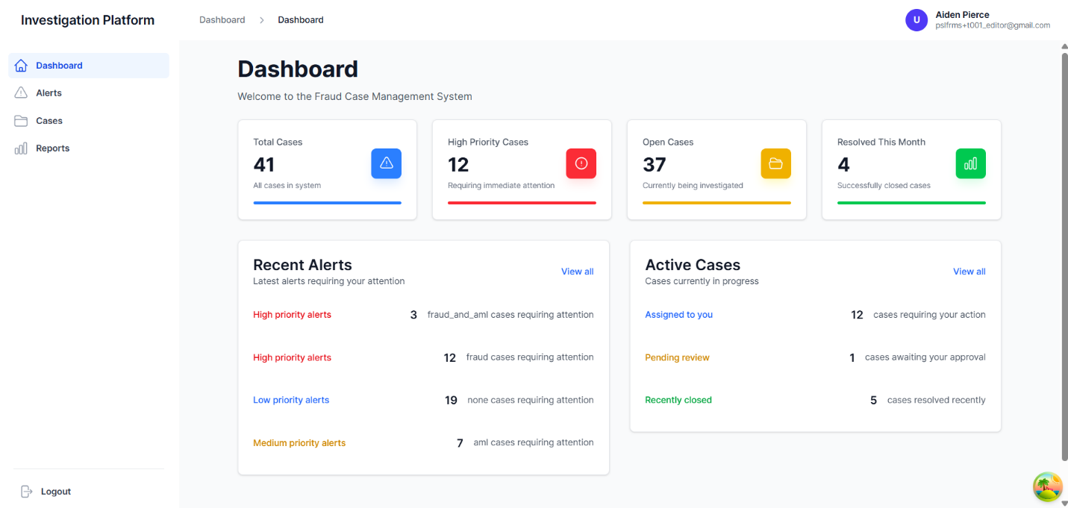
The dashboard layout is unified (not role-specific), but data visibility is governed by role permissions.
Figure 1: Case Management System Dashboard

Dashboard Components

A. Summary Metrics
Displays high-level system statistics:
- Total Cases
- High Priority Cases
- Open Cases
- Resolved This Month
These metrics provide an immediate snapshot of operational workload and risk levels.

B. Recent Alerts
Shows newly generated alerts categorized by priority:
- Low Priority Alerts
- Medium Priority Alerts
- High Priority Alerts
Users may select “View All” to access the detailed Alerts screen.

C. Active Cases
Displays case workload information such as:
- Assigned to You
- Pending Review
- Recently Closed
Clicking any item redirects to a filtered case list.

Left Navigation Panel
The system menu includes:
- Dashboard – Overview page
- Alerts – Alert triage and review
- Cases – Case management screen
- Reports – Reporting and analytics
- Logout – Secure session termination

User Roles: Investigator, Supervisor, Compliance Officer
The CMS enforces structured role separation to ensure accountability and compliance.
At minimum, the system supports the following operational roles:


Investigator
Primary Responsibility: Conduct investigations and document findings.
Typical Capabilities:
- View and claim assigned cases
- Perform preliminary assessment
- Collect and upload evidence
- Add investigation notes
- Update case/task status
- Submit case for closure approval
- Suspend or resume cases (if authorized)

Note: Investigators cannot approve of their own case closures.

Supervisor
Primary Responsibility: Oversight, validation, and approval.
Typical Capabilities:
- Review investigation findings
- Approve or reject case closure
- Reassign cases
- Monitor team workload
- Return cases for further investigation
- Approve reopening requests (if applicable)
Note: Supervisors ensure complete investigation and regulatory adherence before final closure.


Compliance Officer
Primary Responsibility: Regulatory oversight and monitoring.
Typical Capabilities:
- View investigation records
- Monitor AML-related cases
- Review of suspicious activity documentation
- Generate compliance reports
- Review audit logs
Note: Compliance Officers may participate in high-risk or regulatory-sensitive investigations i.e. only cases that are Closed Confirmed

Case Management
The Case Management module allows users to create, review, assign, and manage investigation cases within the CMS. A case may be created manually by an authorized user or automatically generated from a system alert.
Each case is assigned to a unique Case ID and progresses through defined workflow stages.

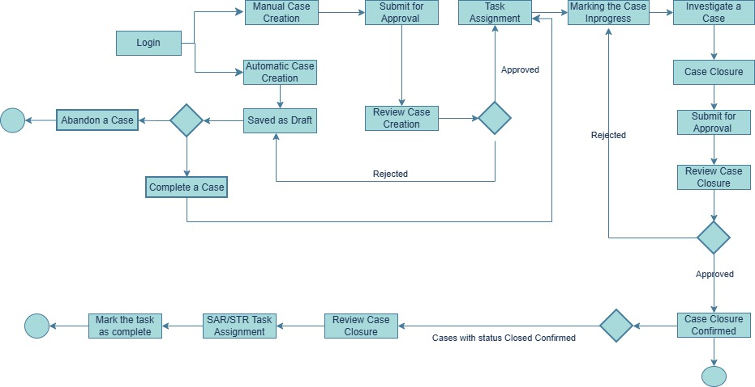
End to End Case Management Workflows

Case Creation
Case creation is the formal initiation of an investigation within the Case Management System (CMS). A case may be created manually when suspicious activity needs to be reviewed independently of system-generated alerts.
Manual case creation ensures that investigations can be initiated based on:
- Customer complaints
- Internal reviews
- Regulatory triggers
- Intelligence inputs
- Escalations outside automated alert monitoring
Once created, every case progresses through a defined approval and task assignment workflow.

4.2.1 Manual Case Creation
Manual case creation consists of two controlled stages:
- Case Creation Submission
- Case Creation Approval (Supervisor)
Both Investigators and Supervisors may create manual cases. However, all manually created cases must pass through the approval stage before investigation can begin.

Stage 1 — Creating a Manual Case

Step 1: Open the Manual Case Form

- Navigate to:
- Press button on Cases Dashboard.
- The “Create Manual Case” screen will open.
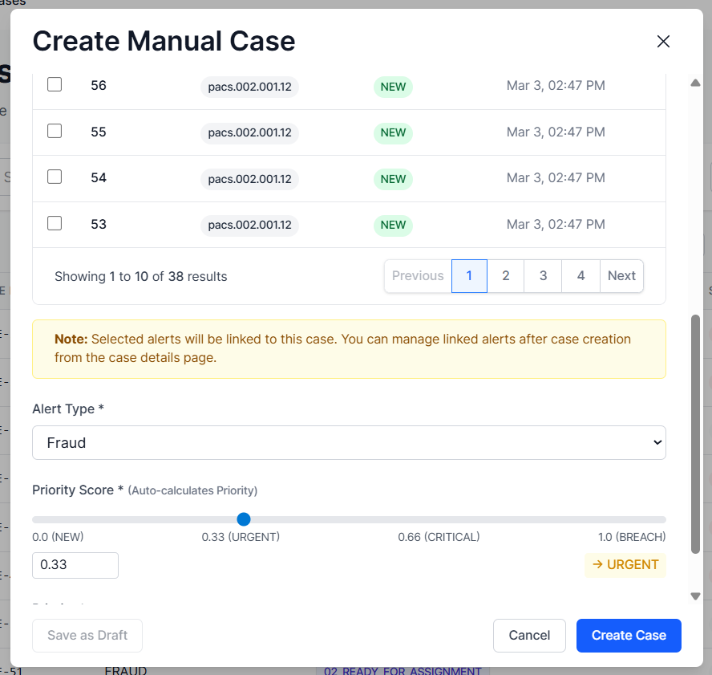
Figure 2: Create Manual Case Screen

Step 2: Complete Required Fields
The following fields must be completed before submitting the case.
- Link Existing Alerts (NALT) (Mandatory)
At the top of the screen, users can link one or more existing alerts.
- Search using Alert ID, Type, or Description.
- Select alerts using the checkbox.
- Selected alerts will be linked to the case.
Note: If no alerts are selected, the case will not be created.
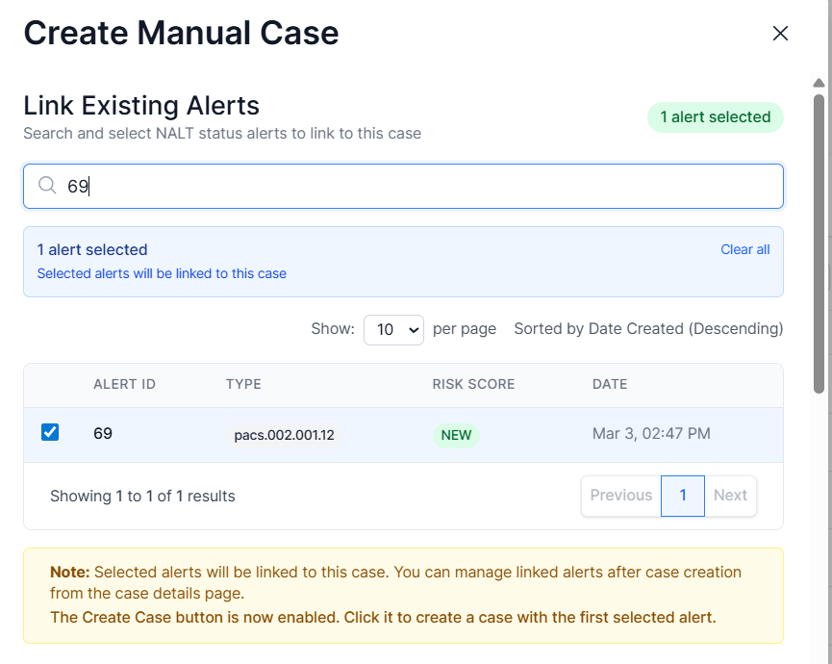
Figure 3: Link Existing Alerts

- Alert Type (Mandatory)
Select the appropriate case category from the dropdown menu.
Examples:
- Fraud
- AML
- Fraud & AML (individual task of each is generated and is investigated in isolation, the status of the case is marked done once both the cases are closed).
This classification determines the investigation category.
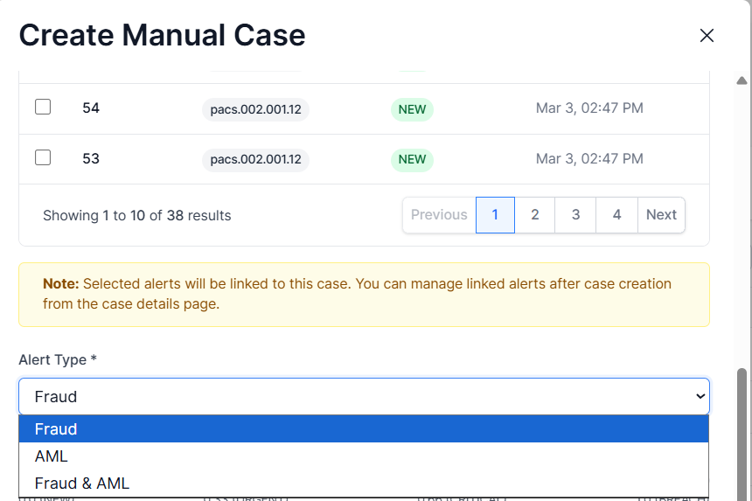
Figure 4: Alert Type

- Priority Score (Mandatory)
Use the slider to define the Priority Score.
- The numeric score is displayed.
- The system automatically calculates the Priority level.
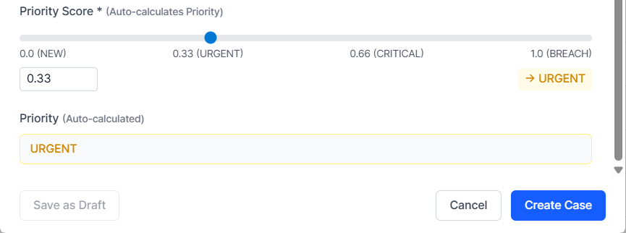
Example mapping:
Figure 5 :Priority Score
Score | Priority
0.0 | NEW
0.33 | URGENT
0.66 | CRITICAL
1.0 | BREACH

- Priority (Auto-Calculated)
This field displays calculated Priority based on the selected Priority Score.
This value cannot be manually edited.

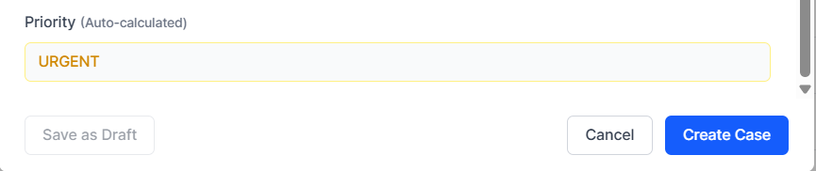
Figure 6: Priority (Auto-Calculated)
Step 3: Submit the Case
- At the bottom of the form, select:
- Save as Draft – Save without submitting
- Cancel – Exit without saving
- Create Case – Submit into workflow
- When Create Case is clicked:
- A unique Case ID is generated.
- The case enters the approval workflow.

What Happens After Submission
Immediately after submission:
- The case appears in the Case List.
- Status is set to 01_PENDING_CASE_CREATION_APPROVAL
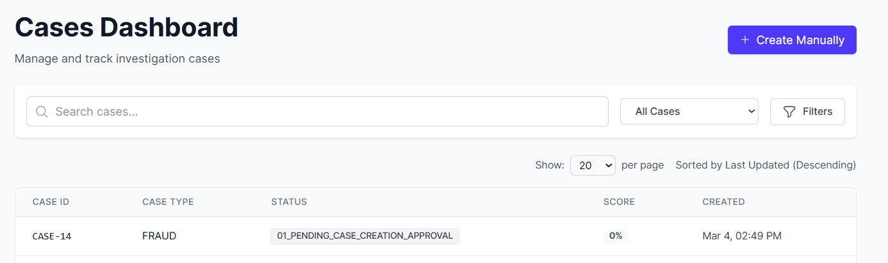
Figure 7: Case List with Updated Status
At this stage:
- Investigation cannot begin.
- The case is awaiting approval.
- A task is automatically created.

Stage 2 — Approval Workflow

Supervisor Review
The Supervisor opens the case and reviews:
- Case ID
- Case Type
- Priority
- Linked Alerts
- Case details
At the bottom of the Case Details screen, the Supervisor selects:
- ✅ Approve Case Creation
- ❌ Reject Case Creation
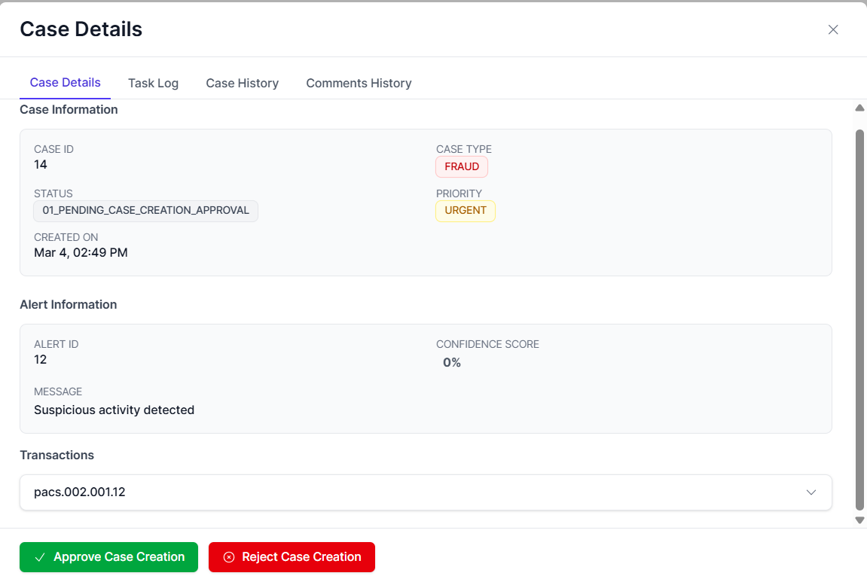
Figure 8: Supervisor Review

- The supervisor accesses the task log, where the system automatically generates a task titled 'Approve Case Creation' after the investigator submits the case for creation.
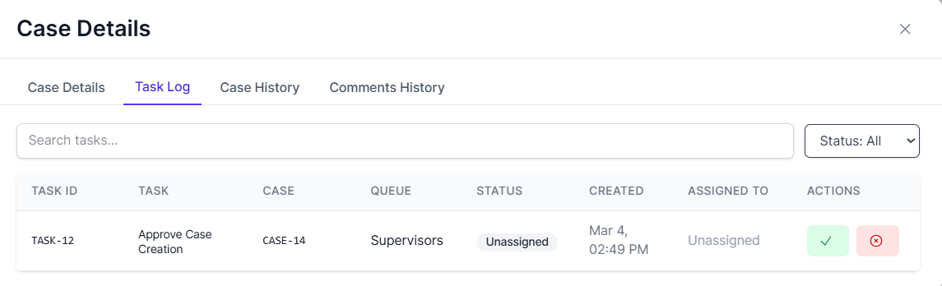
- This task appears in the Supervisor queue only.
Figure 9: Task Creation in Task log for Supervisor

Approval Outcomes
If Approved

When the Supervisor clicks Approve Case Creation from the Case Detail tab or from the Task Log,
- A popup titled Approve Case Creation appears, displaying all the case details. The Supervisor then clicks Approve Case Creation.
- The approval task is marked Completed.
- A new task is created: Investigate Case
- The case status changes to 02_READY_FOR_ASSIGNMENT
- The case is now ready to proceed to the assignment stage.
Figure 10: Status change to 02_READY_FOR_ASSIGNMENT

If Rejected
When the Supervisor clicks Approve Case Creation from the Case Detail tab or from the Task Log,
- A popup titled Reject Case Creation appears, displaying all the case details. The Supervisor adds the rejection reason and then clicks Reject Case Creation.
- Case status changes to 00_DRAFT
Figure 11: Status change to 00_DRAFT

- The Approve Case Creation task is marked with status Completed.
- The Complete New Case task is created and automatically assigned to the investigator who initially created the case.

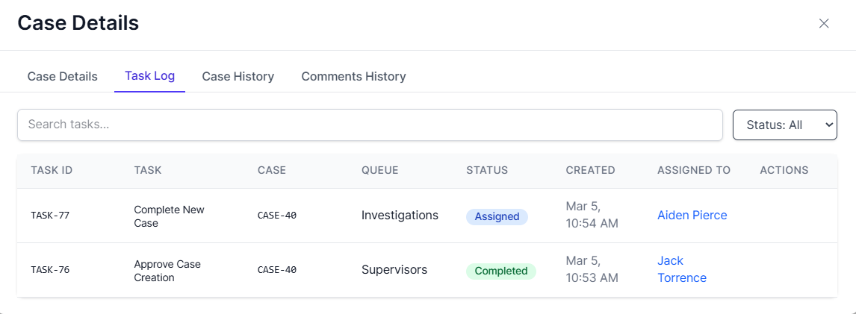
Figure 12: Creation & Assignment of Complete New Case

- A Supervisor or Investigator can now Complete a Case. After the case is marked complete the status gets updated to 02_READY FOR ASSIGNMENT and an Investigate Case task is created. To understand the full workflow, including task assignment, and re-assignment and investigate case please refer to the Task Assignment and Re-assignment and Investigate Case sections later in this document. Follow these sections sequentially to ensure a comprehensive understanding of the entire process. This information is not repeated here to maintain document clarity and simplify updates.
- A Supervisor or Investigator can Abandon a case. The case status gets updated to 99_ABONDONED. No task is created and the workflow ends.

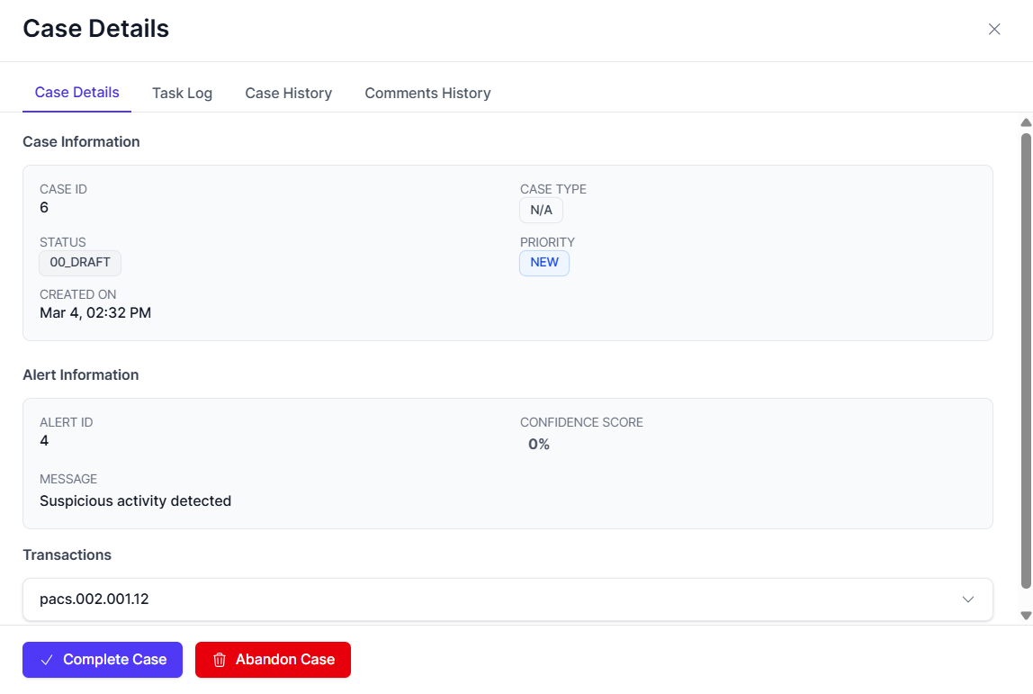
Figure 13: Complete or Abandon a Case

Role Responsibilities Summary
Role | Responsibility in Manual Case Creation
Investigator | Creates and submits case
Supervisor | Reviews and approves or rejects
Supervisor (if creator) | Must also complete approval stage
Supervisor/Investigator | Can complete a case or abandon it (when the supervisor Rejects the case creation), with the case status updated to 02_READY_FOR_ASSIGNMENT or 99_ABANDONED accordingly.

Automatic Case Creation (Alert Triage Module)

Step 1 — Accessing the Alert
- Navigate to the Alerts page in the system.
- From the list of alerts, select the specific alert for which a case is to be created.
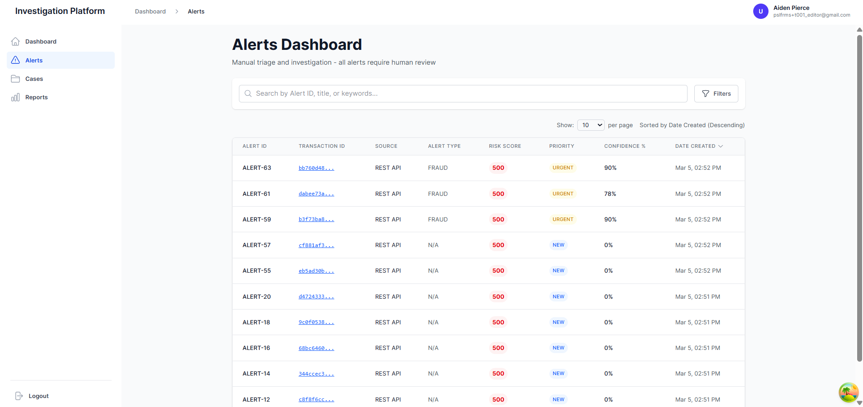
Figure 14: Alerts List with specific alert selected

Step 2 — Updating the Alert
- Once the specific alert is selected, click on the alert to open the Alert Details page.
- In the Alert Details page, click the Update Alert button to begin the case creation process.
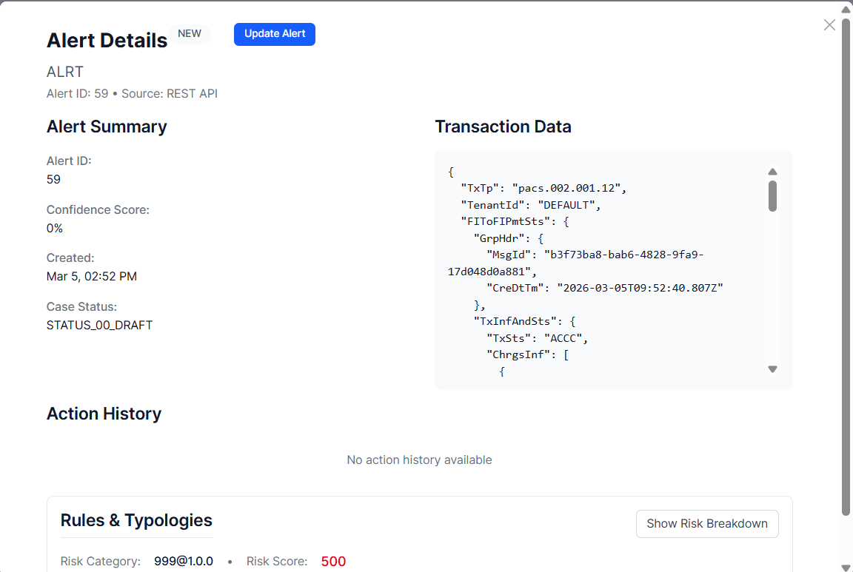
Figure 15:Alert Details page with Update Alert button

Step 3 — Filling in Mandatory Details
- A popup window will appear prompting you to review and update the alert details.
- Fill in all mandatory details required to proceed. This includes:
  - Priority
  - Confidence Score
  - Alert Type
  - Prediction Outcome
  - Notes
- Once the mandatory fields are completed, select Complete Triage.
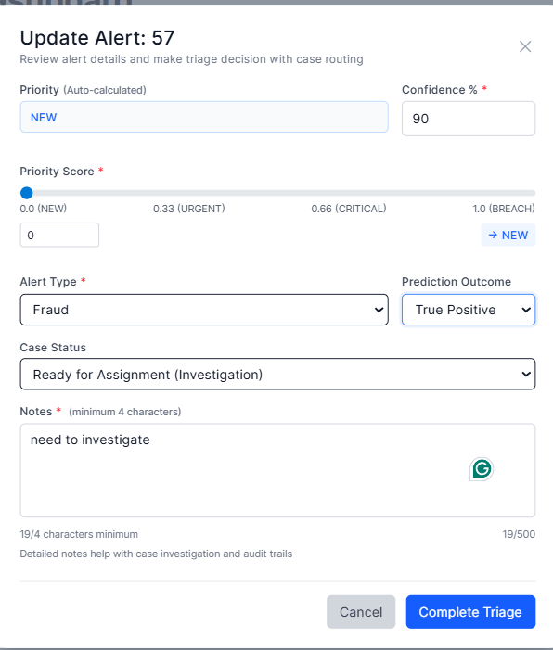
Figure 16: Update Alert popup with mandatory fields filled

Step 4 — Completing the Triage
- After clicking Complete Triage, the system automatically processes the alert.
- The case skips the approval process and is directly created in the CMS as Ready for Assignment.
  - Case status will change to 02_READY_FOR_ASSIGNMENT.
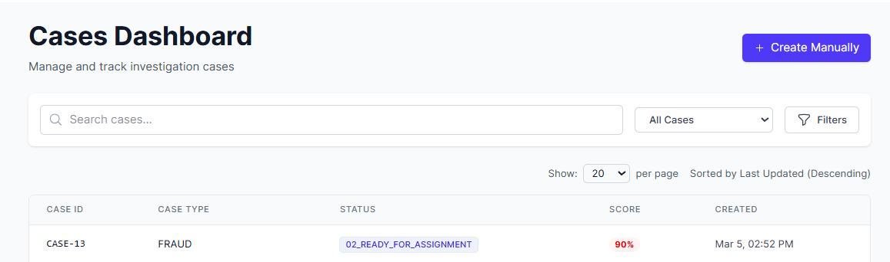
Figure 17:Case List showing the case with 02_READY_FOR_ASSIGNMENT status

Step 5 — Proceeding to the Case Dashboard
- The newly created case will now be visible in the Case Dashboard with a status of Ready for Assignment.
- For further steps, such as task assignment and investigation, refer to the Task Assignment and Investigate Case sections.
- Due to document maintenance, these steps will not be repeated here for clarity and ease of updates.
Notes:
- The case bypasses the Approval Workflow entirely, meaning it will not require manual supervisor approval before proceeding to the investigation stage.
- The case will directly move to the assignment stage, and the Triage Outcome is based on the confidence score set during the alert triage.

Task Assignment and Re-assignment
Once a manual case has been approved by the Supervisor, or if the case creation is rejected by the Supervisor and Complete Case is selected by the Investigator or Supervisor, the case proceeds to the assignment stage. This stage ensures clear ownership and accountability before the investigation begins.

4.3.1 Assigning Task to Investigators

A. When Does Assignment Occur?
Assignment occurs after:
- A case is created
- The Supervisor approves the case or rejects the case creation and complete case is selected by the investigator or supervisor.
- The system generates the “Investigate Case” task.
- The case status becomes 02_READY_FOR_ASSIGNMENT.
At this stage, the task appears as Unassigned in the Task Log.
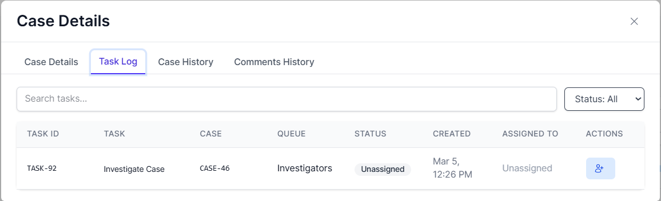
Figure 18: Task Log showing “Investigate Case” → Status: Unassigned

B. Role-Based Assignment Permissions
Investigator
- May assign the task to himself/herself only.
- Cannot assign tasks to other Investigators.
Supervisor
- May assign the task to:
  - Himself/herself
  - Any available Investigator

C. Navigation to Assign a Task
To assign a task:
- Navigate to Cases from the left-hand menu.
- Select the relevant Case ID.
- In the Case Details screen, click the Task Log tab in the top navigation bar.

- Locate the task titled Investigate Case.
Figure 19: Case Details → Task Log view


D. Assigning the Task
- In the Task Log, click the Action icon next to the “Investigate Case” task.
- The Assign Task popup window will appear.
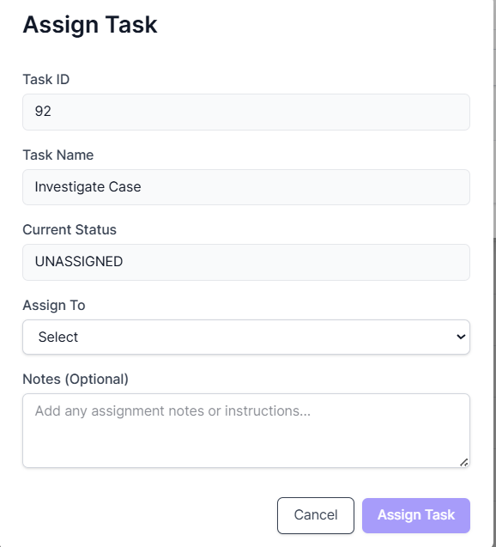
Figure 20: Assign Task Popup Window
The popup displays:
- Task ID
- Task Name
- Current Status (UNASSIGNED)
- Assign To (dropdown list)
- From the dropdown list, select the appropriate user.
- Click Assign Task.

E. System Behavior After Assignment
Once the task is assigned:
- Task status changes from: Unassigned → Assigned
- The selected user appears in the Assigned To column.
- Case status changes from: 02_READY_FOR_ASSIGNMENT → ASSIGNED
At this stage:
- The case is officially owned by a user.
Figure 21: 02_READY_FOR_ASSIGNMENT → ASSIGNED

4.3.2 Re-assigning Tasks
Task re-assignment allows an investigation task that is already assigned to one Investigator to be transferred to another authorized user.
Re-assignment ensures continuity of investigation in cases such as:
- Investigator unavailability
- Workload redistribution
- Escalation requirements
- Supervisor intervention

A. Role Permissions for Re-assignment
Investigator
- May re-assign the task.
- Typically used when the Investigator is unable to continue the investigation.
Supervisor
- May re-assign the task to:
  - Any available Investigator
  - Himself/herself (if applicable)
Supervisors retain oversight authority over task ownership.

B. Navigation to Re-assign a Task
To initiate re-assignment:
- Navigate to Cases.
- Select the relevant Case ID.
- Click on the Task Log tab.
- Locate the task titled: Investigate Case.

- In the Actions column, you will see multiple icons, Click the Reassign Icon.
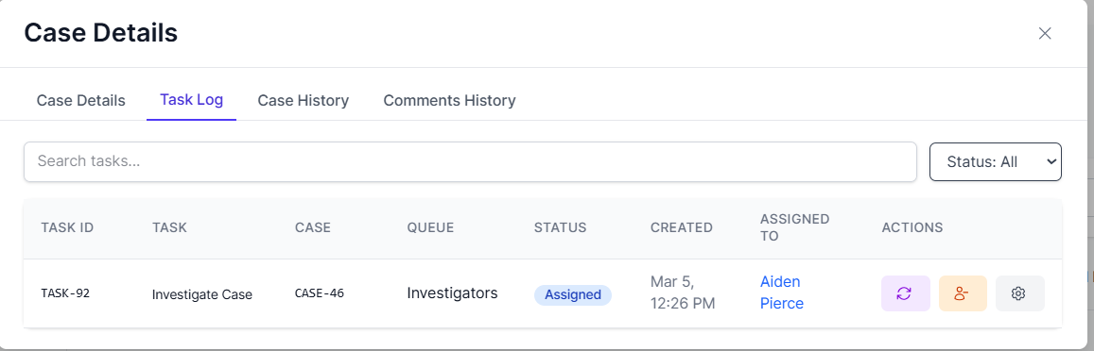
Figure 22: Task Log showing assigned task with reassign icon

C. Reassign Task Popup
After clicking the reassign icon, the Reassign Task popup appears.
The popup displays:
- Task ID
- Task Name
- Current Assignee
- Reassign To (dropdown list)
- Note (Mandatory Field)
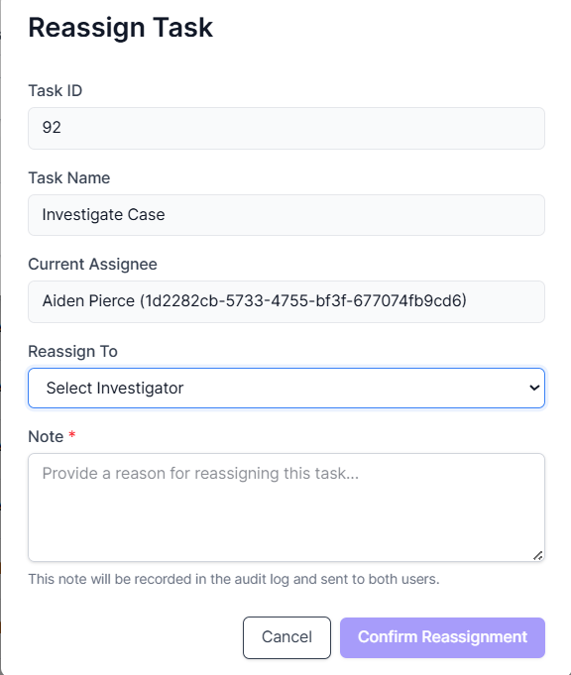
Figure 23: Reassign Task popup window

D. Mandatory Note Requirement
A Note must be entered before confirming reassignment.
Example:
“Due to unavailability, reassigning to Sara Collins.”
The note:
- It is recorded in the audit log
- It is visible in Case History
- It is sent to both users
Reassignment cannot proceed without entering a note.

E. Confirming Reassignment
After:
- Selecting the new assignee from the dropdown.
- Entering the mandatory note.
Click: Confirm Reassignment

F. System Behavior After Re-assignment
Once confirmed:
- The task remains in Assigned status.
- The Assigned To field updates to the new Investigator.
- The task is removed from the previous Investigator’s queue.
- The task appears in the new Investigator’s queue.
- The action is recorded in:
  - Task Log
  - Case History
  - Audit Log
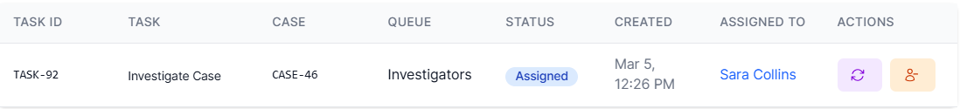
Figure 24: Task Log showing updated Assigned To field

G. Status Impact
Re-assignment does not change the case stage.
- Case Status remain unchanged i.e. ASSIGNED.
- Only task ownership changes i.e. Assigned to.
- Investigation continues under the new assignee.

4.3.3 Unassigning a Task
The Unassign function allows an assigned task to be returned to the unassigned state. This action removes ownership of the task and makes it available for reassignment.
Unassignment may be required in cases such as:
- Investigator unavailability
- Incorrect assignment
- Workload redistribution
- Supervisor intervention

A. Who Can Unassign a Task?
Investigator
- May unassign a task currently assigned to himself/herself.
Supervisor
- May unassign tasks assigned to any Investigator.
Supervisors retain oversight authority over task ownership.

B. Navigation to Unassign a Task
To unassign a task:
- Navigate to Cases.
- Select the relevant Case ID.
- Click the Task Log tab.

- Locate the assigned task titled: Investigate Case

- In the Actions column, you will see multiple action icons, Click the Unassign Icon.
Figure 25: Task Log showing assigned task with unassign button visible
- After clicking the Unassign icon, the Unassign Task popup appears.
- Fill in the mandatory fields and click the button Unassign Task.

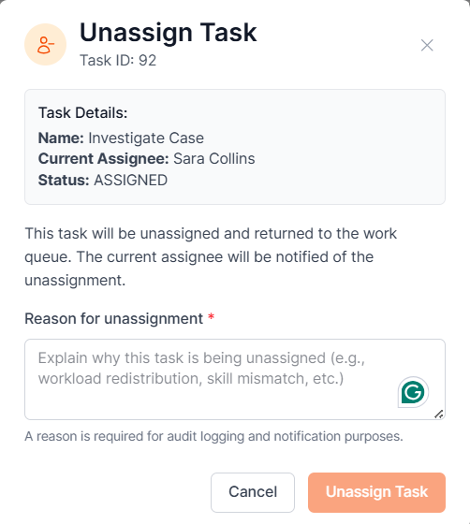
Figure 26: Unassign Task Popup

C. System Behavior After Unassignment
Once the unassign action is confirmed:
- The task status changes from: Assigned → Unassigned
- The Assigned To field becomes blank.
- The task returns to the Investigators queue as available.
- The task is removed from the previous Investigator’s active queue.
- The case status may revert to 02_READY_FOR_ASSIGNMENT

D. Queue Visibility After Unassignment
User | Visibility After Unassignment
Previous Investigator | Task no longer appears as assigned
Other Investigators | Task appears as Unassigned
Supervisor | Can view updated status in Task Log

Investigation Process
The Investigation Process begins once a task has been assigned to an Investigator and formally marked In Progress.
This section outlines the end-to-end investigation workflow, from initiation to completion.

Initiating an Investigation
An investigation officially begins when the assigned Investigator updates the task status to In Progress.

A. Marking the Task as In Progress
- Navigate to: Cases → Select Case → Task Log
- Locate the assigned task “Investigate Case.”

- Click the Status Icon.
- In the popup window, select: In Progress
- Confirm the update.
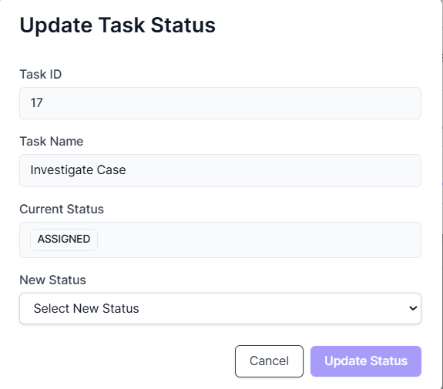
Figure 27: Update Task Popup

B. Opening the Investigation Workspace
After marking the task In Progress:

- In the Task Log, click the View Icon.
- The Task Details screen opens.
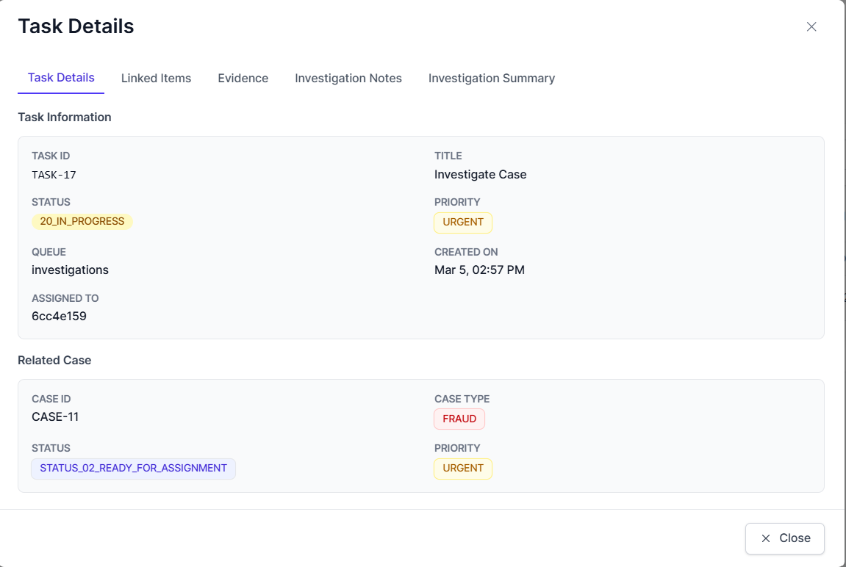
This screen contains multiple tabs used throughout the investigation lifecycle.
Figure 28: Task Details with tab navigation visible

Evidence Collection and Documentation
Within the Task Details screen, the Investigator will collect and document supporting information.

5.2.1 Linked Items (Transaction History)
Navigate to the Linked Items tab.
This section displays:
- Related transactions
- Past 90 days transaction history
- System-linked transactional data

5.2.2 Evidence Upload (Evidence Tab)
Navigate to the Evidence tab.
The following categories are available:
- KYC / EDD Report
- Sanctions Screening
- Adverse Media Screening
- Others
To upload evidence:
- Click Upload Evidence.
- Select the relevant category.
- Attach supporting documentation.
- Save.
All uploaded evidence becomes part of the case record.
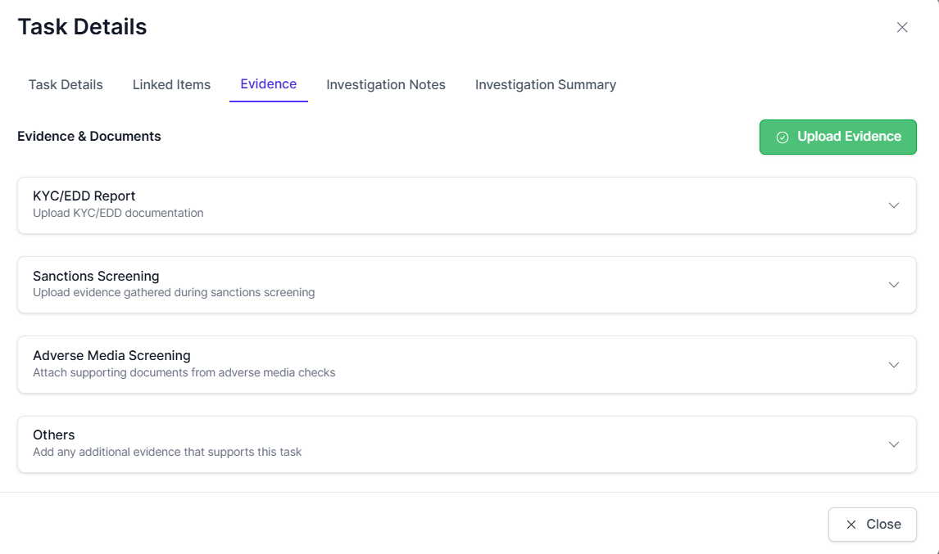
Figure 29: Evidence tab with upload button visible

Conducting the Investigation (Visualization)
The Investigator performs structured analysis using transactional data, documentation, and visual tools.

Case Notes and Remarks
Documentation is critical for audit and supervisory review.

A. Recording Investigation Notes
Navigate to the Investigation Notes tab.
- Enter findings, observations, and reasoning.
- Use formatting tools if required.
- Click Save Investigation Notes.
Notes are recorded in the system audit trail.
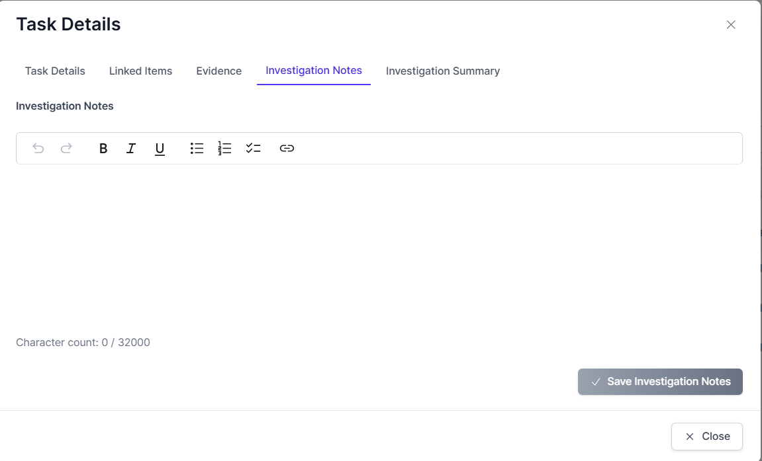
Figure 30: Investigation Notes tab with editor visible

B. Reviewing Investigation Summary
Navigate the Investigation Summary tab.
This screen displays:
- Summary of Investigation Notes
- Evidence Summary
- Case metadata (Case ID, Type, Priority, Created Date)
- Assigned Investigator
This acts as a consolidated view before completion.
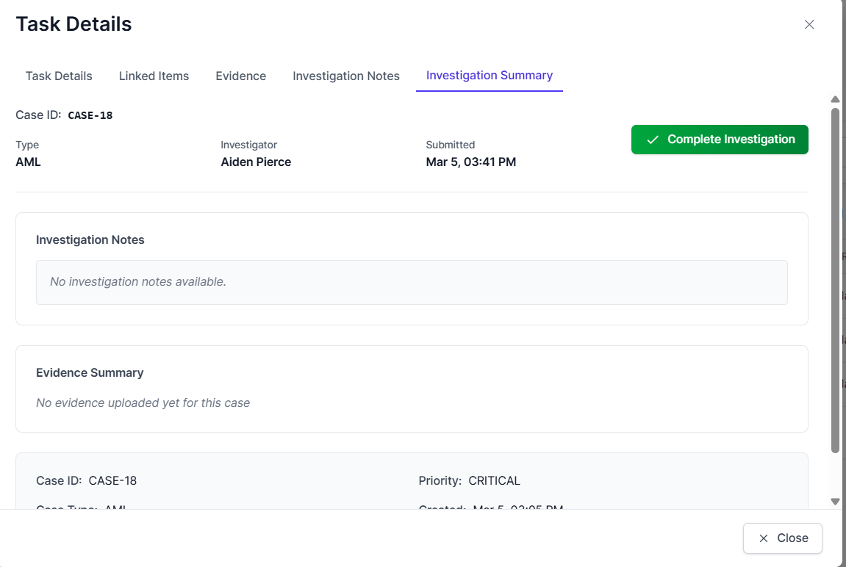
Figure 31: Investigation Summary tab

Completing the Investigation Task
Once analysis, documentation, and evidence upload are complete:
- Navigate to Investigation Summary tab.
- Click Complete Investigation
- A confirmation popup appears.
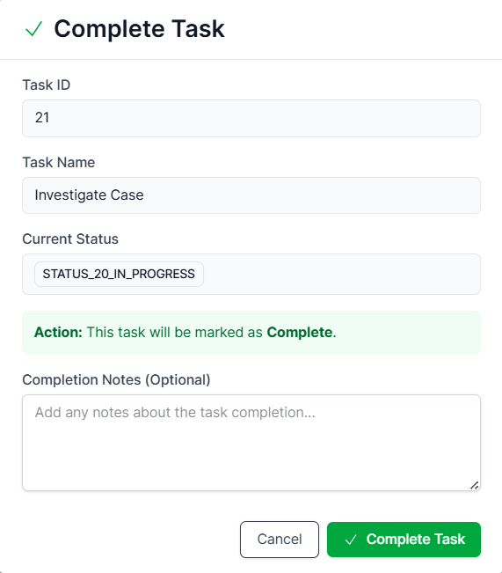
Figure 32: Complete Task popup

A. Confirming Completion
- The popup displays:
- Task ID
- Task Name
- Current Status (IN_PROGRESS)
- Completion Notes (Optional)
- Click: Complete Task
- The investigation phase is now formally closed.

Investigation Lifecycle Summary
Stage | Task Status | Case Status
Assigned | Assigned | ASSIGNED
Investigation Started | In Progress | IN_PROGRESS
Investigation Completed | Completed | Pending Supervisor Action

Suspend and Resume a Case
A Supervisor or Investigator can suspend a case at any point during the investigation process, before the case is closed and submitted for supervisor approval. Suspending a case allows users to pause the investigation when additional information or resolution of blocking issues is needed. Once the case is suspended, it can be resumed when the issue is resolved.

Suspending a Case
To suspend a case:
- Open the Case Details page for the case to be suspended.
- Click the Suspend Case button.

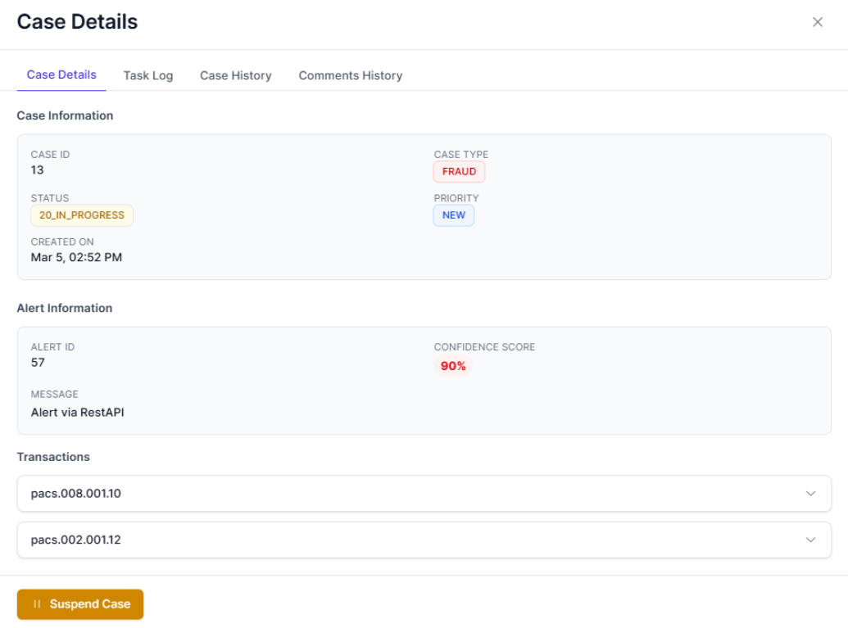
Figure 33: Case Details page with Suspend Case button visible

- In the Suspend Case popup:
  - Auto-Select the task to suspend (e.g., Investigate Case).
  - Provide a reason for suspension (e.g., "Pending additional information").
- Click Suspend Case to confirm.

Resuming a Case
To resume a suspended case:
- Open the Case Details page for the suspended case.
- Click the Resume Case button.
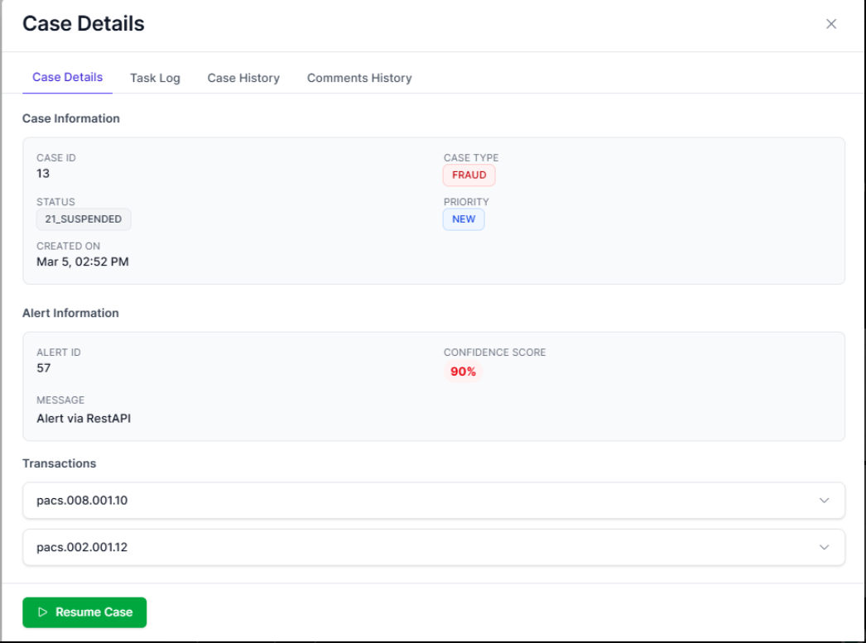
Figure 34: Case Details page with Resume Case button visible
- In the Resume Case popup: Provide a reason for resumption (e.g., "Blocking issue resolved").
- Click Resume Case to confirm.

Note:
- Suspending a case halts progress and no further tasks can be executed until the case is resumed.
- Resuming a case brings it back into progress, unlocking the investigation task for the assigned Investigator.

Case Closure and Approval
Case Closure begins after the Investigator has completed the Investigation Task.
This section outlines the workflow from closure initiation to final supervisory approval and report archiving.

Case Closure Process (Investigator Action)
Once the Investigation Task is marked Completed, the Investigator can initiate case closure.

A. Initiating Case Closure
- Navigate to: Case Details → Case Details Tab
- Click the Close Case Button
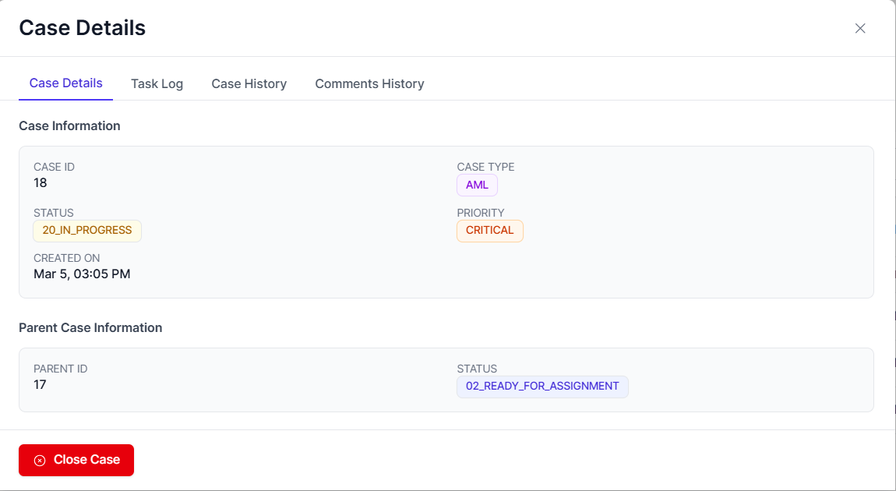
Figure 35: Close Case button visible under Case Details

B. Complete Case Investigation Popup
- A popup titled: Complete Case Investigation appears.
- The Investigator must:
- Select Recommended Outcome (Mandatory)
- Provide Investigation Findings Notes
- Click Submit for Approval

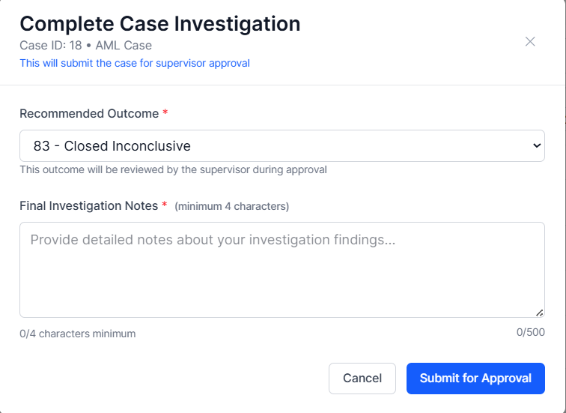
Figure 36: Complete Case Investigation popup

C. System Behavior After Submission
- Case Status updates to: PENDING_FINAL_APPROVAL
- Case is removed from Investigator active queue
- Case moves to Supervisor queue
- “Review Case Closure” button becomes visible
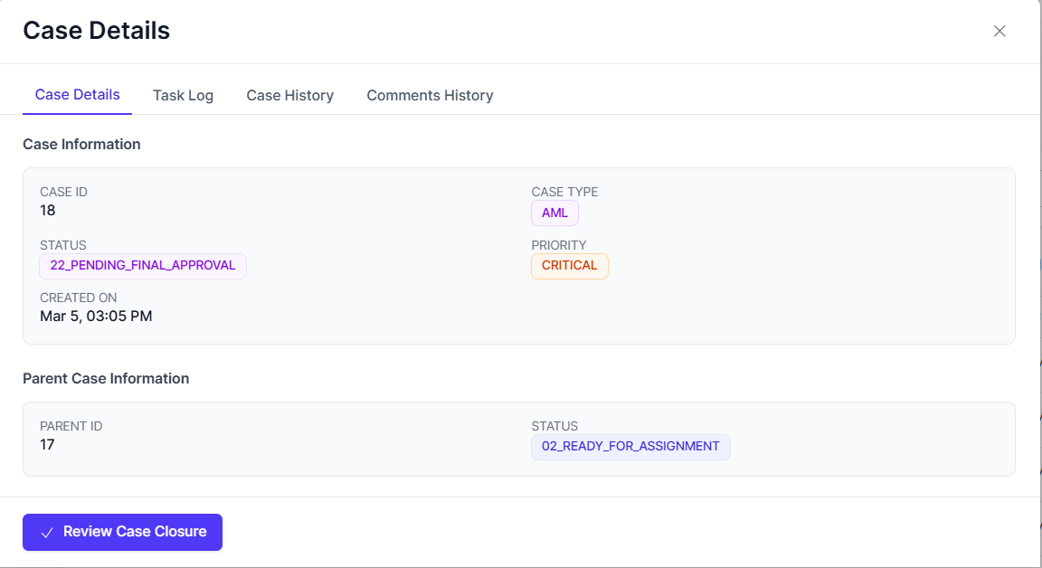
Figure 37: Case Status showing 22_PENDING_FINAL_APPROVAL

Auto Case Closure
After a case is created, it enters the Alert Triage Module (ATM) for evaluation. If the case meets certain criteria, the system can automatically close the case without manual intervention.
Flow for Automatic Case Closure:
- Triage Evaluation:
  - The ATM evaluates the alert based on predefined rules or AI-driven models.
  - It assigns a confidence score to determine whether the case requires further investigation.
- Automatic Closure Criteria:
  - If the case’s confidence score is high enough, indicating low risk or a false positive, the system automatically closes the case.
  - The status is updated to 81_CLOSED_REFUTED (if false positive) or 82_CLOSED_CONFIRMED (if validated, but no further action is needed).
- Audit and Logging:
  - The closure decision is automatically logged into the system for compliance and audit purposes.

Final Outcome Selection
The Investigator must select one of the following outcomes:

Closed Refuted (81)
Used when:
- The alert is determined to be false positive
- No suspicious activity is confirmed
- Investigation disproves initial suspicion
System Code: STATUS_81_CLOSED_REFUTED

Closed Confirmed (82)
Used when:
- Suspicious activity is validated
- Fraud or AML breach is confirmed
- Escalation or reporting may be required
System Code: STATUS_82_CLOSED_CONFIRMED

Closed Inconclusive (83)
Used when:
- Evidence is insufficient
- Unable to conclusively confirm or refute suspicion
- Monitoring may continue
System Code: STATUS_83_CLOSED_INCONCLUSIVE

Supervisory Approval
Once submitted, the Supervisor must review and approve or reject the closure.

A. Supervisor Initiates Review

- Supervisor opens the case.
- Clicks

B. Case Closure Review Popup
The Case Closure Review screen appears with two options:
- Approve Case Closure
- Reject Case Closure
Supervisor can:
- Review Investigator’s Notes
- Review Recommended Outcome
- Modify Final Outcome (if required)
- Add Supervisor Comments
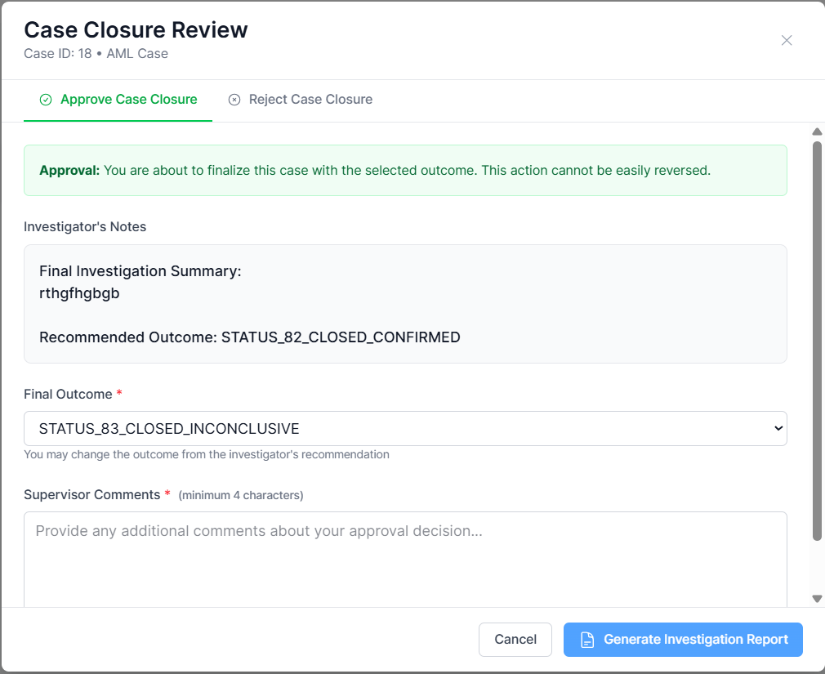
Figure 38: Case Closure Review screen

C. Generating Investigation Report
Before final approval:
- Click Generate Investigation Report
- A new popup appears.
- Click Generate Report
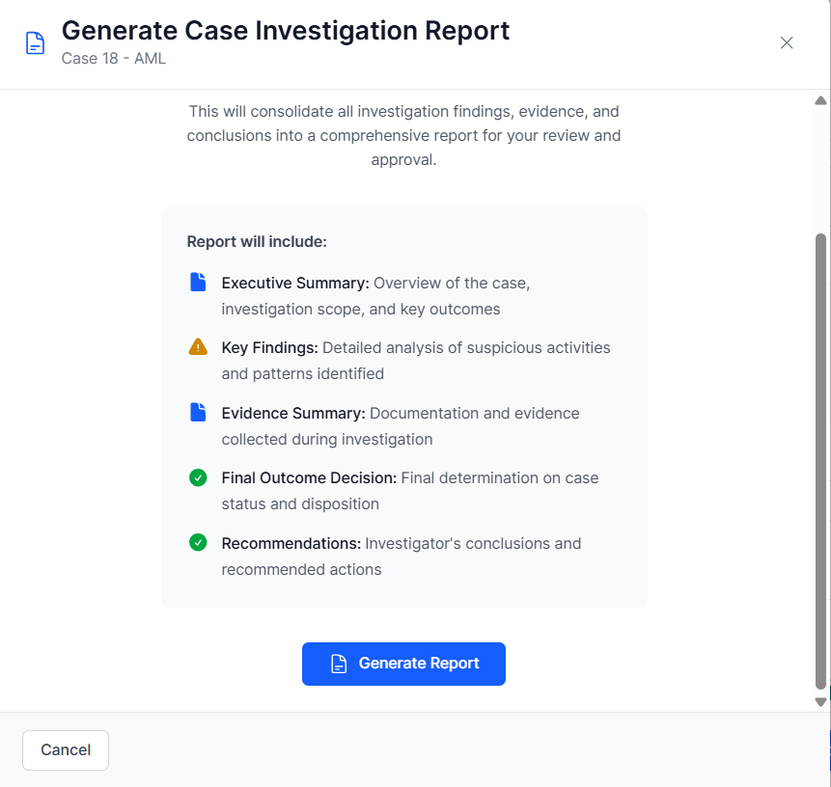
Figure 39: Generate Case Investigation Report popup

D. Finalizing and Approving the Report
After report generation:
- Click Finalize & Approve Report
- Confirmation popup appears:
  - Locks the report
  - Sets final case outcome
  - Archives report
  - Notifies stakeholders
- Click Confirm Approval
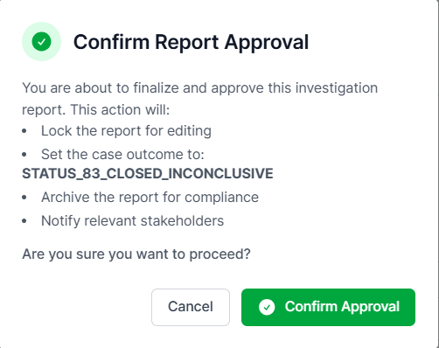
Figure 40: Confirm Report Approval popup

E. If Supervisor Rejects Case Closure
If Reject Case Closure is selected:
- Supervisor must provide rejection reason (Minimum 4 characters)
- Case returns to Investigator queue
- Case status reverts to: IN_PROGRESS
- Investigation reopens
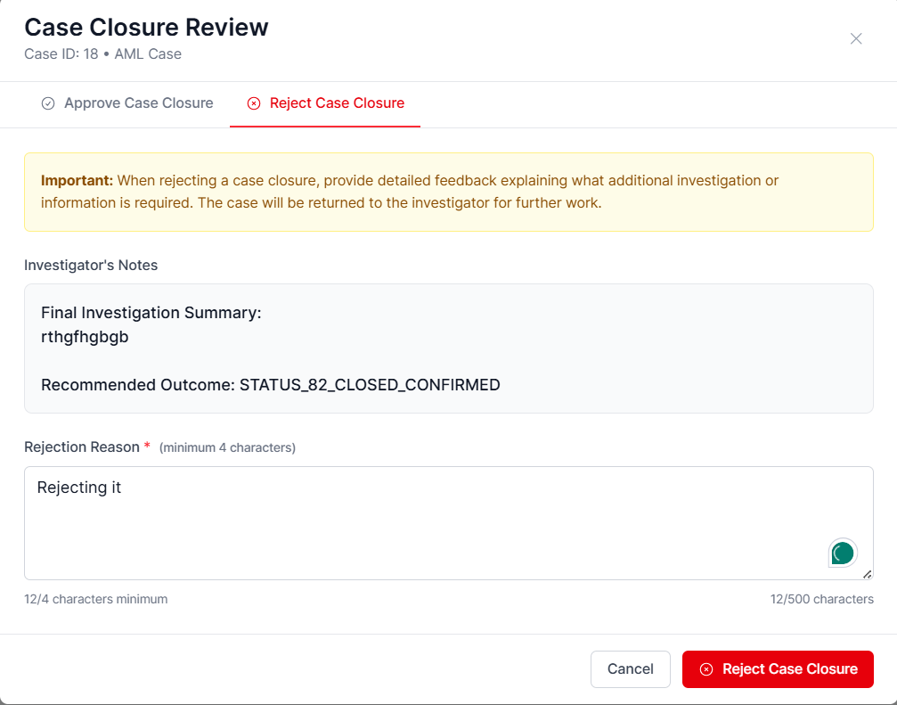
Figure 41: Reject Case Closure tab

Post-Closure Actions
After final approval:
✔ Investigation Report archived
✔ Case status finalized
✔ Case removed from operational queues
✔ Audit log updated
✔ Compliance record preserved
✔ Notifications triggered
The case lifecycle is now complete.

Complete Case Lifecycle Overview
Stage | Actor | Status
Case Created | Investigator/Supervisor | PENDING_APPROVAL
Case Approved | Supervisor | ASSIGNED
Investigation Started | Investigator | IN_PROGRESS
Investigation Completed | Investigator | COMPLETED
Closure Submitted | Investigator | PENDING_FINAL_APPROVAL
Closure Approved | Supervisor | CLOSED_*

Audit and Compliance Features
The CMS ensures full auditability, regulatory traceability, and structured compliance workflows. All actions performed within a case are logged, time-stamped, and attributable to specific users.

Comments History and Case History
CMS maintains two independent audit trails:
- Case History (System Events Timeline)
- Comments History (User Notes and Decisions)
Both are immutable and timestamped.

A. Case History (System-Level Timeline)
Accessible via: Case Details → Case History Tab
The Case Timeline records:
- Task assignments
- Status transitions
- Evidence uploads
- Task completion
- Final approvals
- SAR/STR updates
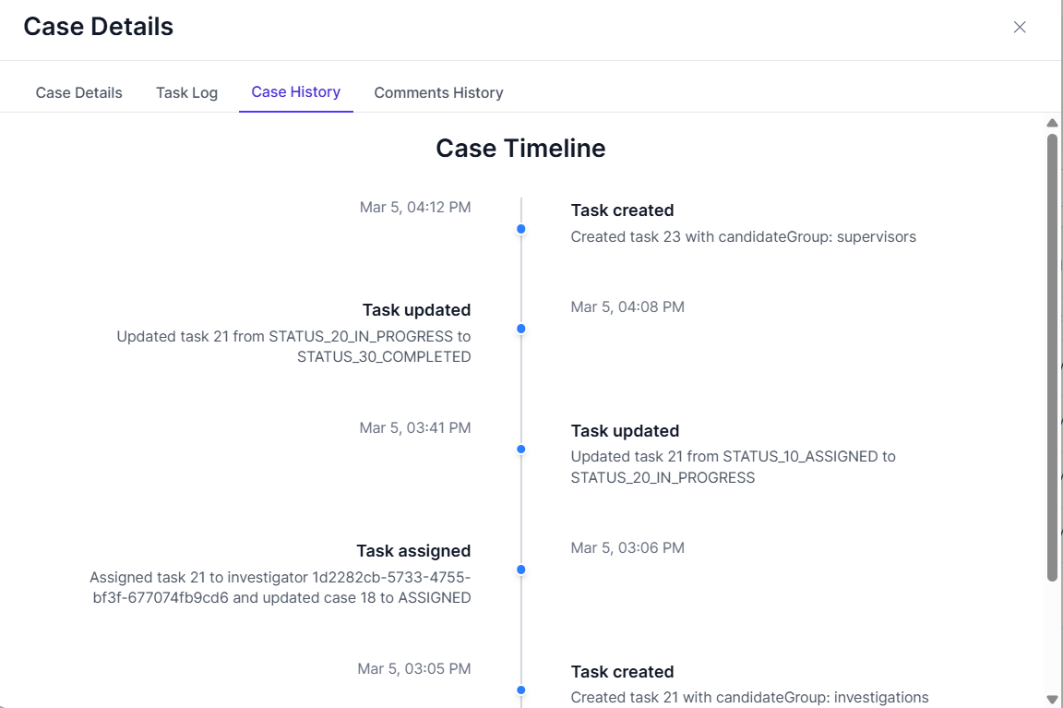
Figure 42: Case Timeline showing task updates and evidence upload events

B. Comments History (User-Level Audit Trail)
Accessible via: Case Details → Comments History Tab
This section records:
- Investigator notes
- Supervisor approval comments
- Final outcome confirmation
- Compliance notes
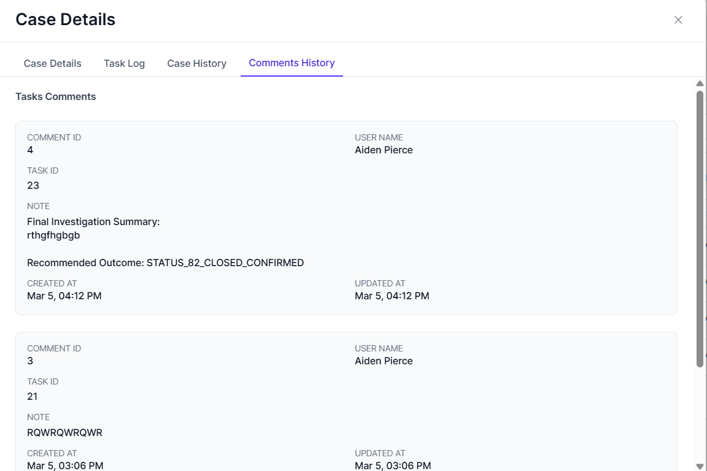
Figure 43: Comments History showing Supervisor Approval and Final Outcome

Compliance Workflow
The Compliance Officer operates under controlled access rules.

A. Visibility Restrictions
Compliance Officer can:
✔ View only cases with status: 82_CLOSED_CONFIRMED
❌ Cannot access:
- Refuted cases
- Inconclusive cases
- Cases still under investigation

B. Investigation Report Access
Within Case Details:
Compliance Officer can click: View Investigation Report

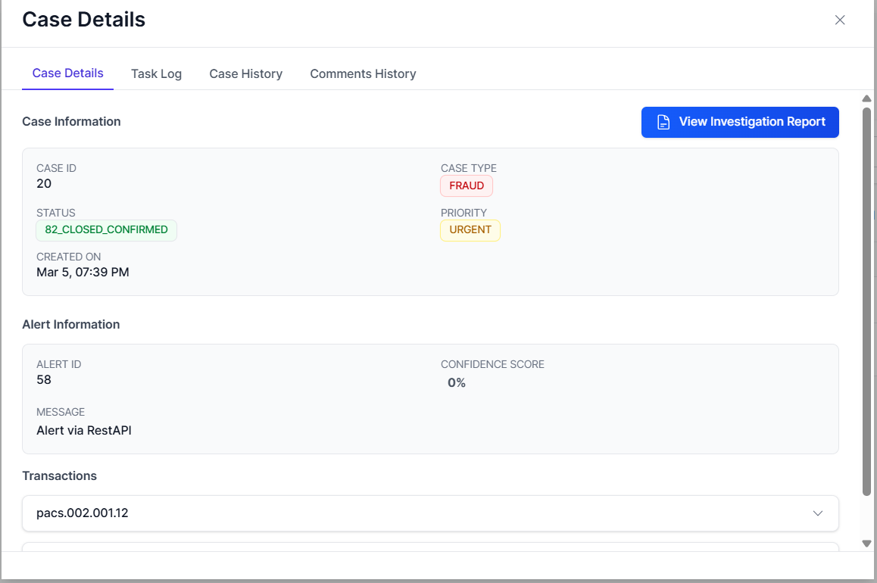
Figure 44: View Investigation Report button
This allows review of:
- Investigation findings
- Final outcome
- Supporting evidence
- Supervisor approval record

C. SAR/STR Task Generation
Once case is Closed Confirmed, a new task appears:
Task: SAR/STR Filing
Queue: Compliance
Status: Unassigned

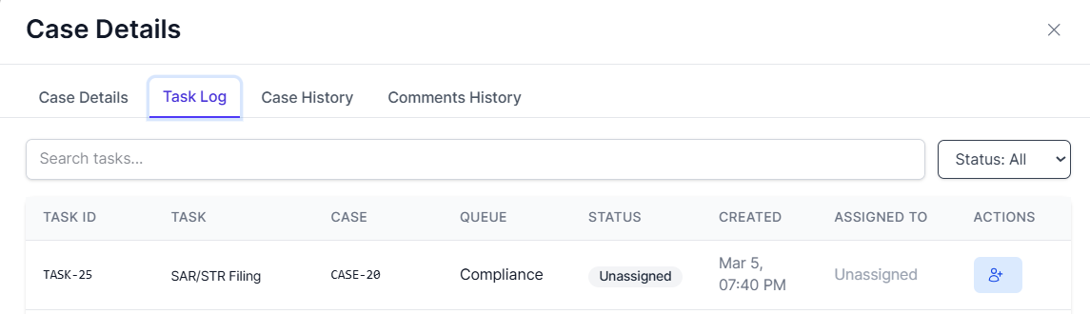
Figure 45: Task Log showing SAR/STR Filing — Unassigned

Regulatory Reporting (SAR/STR Filing Process)
The SAR/STR workflow follows the same task lifecycle pattern explained in previous sections.

A. Assigning SAR/STR Task
- Compliance Officer assigns tasks to self or another compliance user.
- Task status becomes: ASSIGNED

B. Mark Task In Progress
- Click Update Status button
- Change status to: IN_PROGRESS
This activates SAR/STR documentation phase.

C. Open SAR/STR Filing Popup
Click SAR/STR task → Popup appears: SAR/STR Filing Documentation
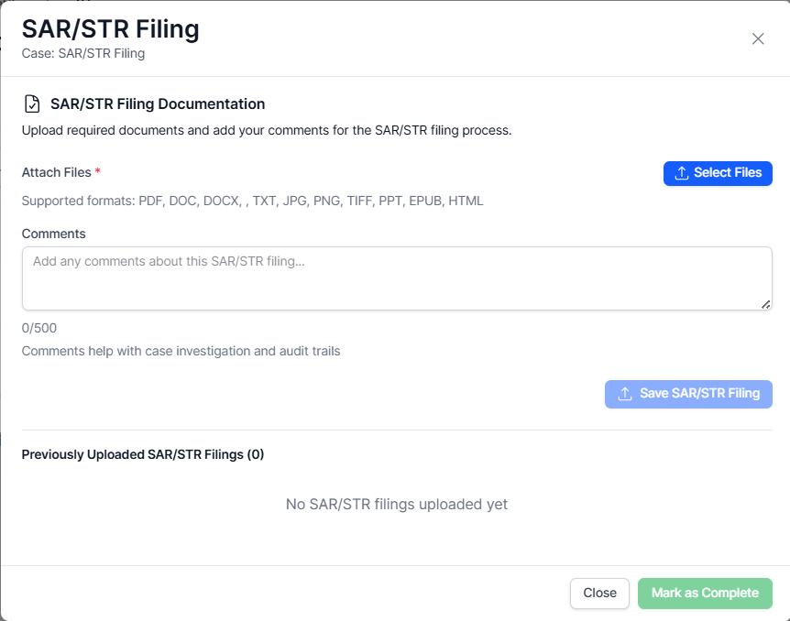
Figure 46: SAR/STR Filing popup
Compliance Officer must:
- Attach required files (Mandatory)
- Add regulatory comments (Optional but recommended)
- Click Save SAR/STR Filing
Supported formats include:
PDF, DOC, DOCX, TXT, JPG, PNG, TIFF, PPT, EPUB, HTML

D. Mark SAR/STR Task Complete
After documentation upload:
- Click Mark as Complete
- Complete Task popup appears
- Click Complete Task
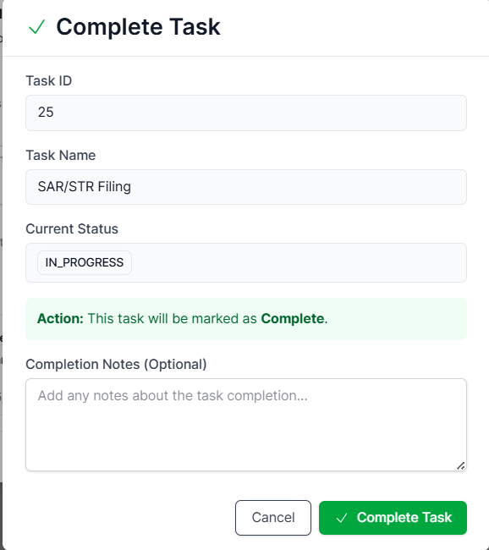
Figure 47: Complete Task popup for SAR/STR

C. Status Code Enforcement
Each stage uses system-coded statuses:
Code | Meaning
STATUS_10_ASSIGNED | Task assigned
STATUS_20_IN_PROGRESS | Task active
STATUS_30_COMPLETED | Task finished
STATUS_82_CLOSED_CONFIRMED | Confirmed fraud
SAR/STR Task Completed | Regulatory filed

This prevents unauthorized workflow manipulation.

End-to-End Compliance Lifecycle
Stage | Actor | Control
Investigation | Investigator | Notes & evidence logged
Approval | Supervisor | Final outcome locked
Regulatory Filing | Compliance | SAR/STR archived
Audit Trail | System | Immutable timeline

Appendices

Glossary of Terms
This glossary defines key functional, technical, and regulatory terms used within the CMS User Manual.

Alert:
A system-generated or externally triggered notification indicating potentially suspicious activity requiring review and investigation.

Alert ID:
Unique identifier assigned to an alert record within the system.

Assigned Status (STATUS_10_ASSIGNED):
Task state indicating that responsibility has been allocated to a specific user.

Audit Trail:
Immutable record of all system events, status transitions, user actions, and comments associated with a case.

Case:
A structured investigation entity created to assess an alert or suspicious activity.

Case ID:
Unique identifier assigned to each case within CMS.

Case History:
System-generated chronological log of all case events including assignments, status changes, evidence uploads, and approvals.

Closed Confirmed (STATUS_82_CLOSED_CONFIRMED):
Final case outcome indicating suspicious activity has been validated.

Closed Refuted (STATUS_81_CLOSED_REFUTED):
Final case outcome indicating the suspicion was disproven.

Closed Inconclusive (STATUS_83_CLOSED_INCONCLUSIVE):
Final case outcome indicating insufficient evidence to confirm or refute suspicion.

Comments History:
User-level audit record containing notes, approvals, rejection comments, and final outcome confirmations.

Compliance Officer:
User role responsible for regulatory reporting (e.g., SAR/STR filing) after a case is confirmed.

Evidence Upload:
Process of attaching supporting documentation to a case or task for investigation or regulatory purposes.

Event Log:
System-level record capturing workflow transitions and operational activities.

In Progress (STATUS_20_IN_PROGRESS):
Task state indicating active investigation or active compliance processing.

Investigation Report:
Structured report generated upon case closure summarizing findings, outcome, and evidence.

Investigator:
User role responsible for conducting case analysis, uploading evidence, and recommending final outcomes.

Regulatory Reporting:
Process of submitting mandatory reports (e.g., SAR/STR) to regulatory authorities.

Reassign Task:
Action allowing a Supervisor or authorized user to transfer task ownership to another user.

Role-Based Access Control (RBAC):
Security mechanism ensuring users can access only authorized cases and functions based on role.

SAR (Suspicious Activity Report):
Regulatory report filed when confirmed suspicious or fraudulent activity is identified.

STR (Suspicious Transaction Report):
Regulatory filing related specifically to suspicious financial transactions.

SAR/STR Filing Task:
Compliance workflow task triggered when a case is marked as Closed Confirmed.

Status Code:
System-defined numeric or textual representation of a workflow stage.

Supervisor:
User role responsible for approving case creation, reviewing investigation findings, and confirming final case outcomes.

Task:
Workflow unit assigned to a user representing an actionable step within a case lifecycle.

Task Log:
Tab within Case Details showing all tasks associated with a case.

Task Status:
Current state of a task (Unassigned, Assigned, In Progress, Completed).

Unassigned Status:
Task state indicating no user has yet taken ownership.

Workflow:
Predefined sequence of status transitions and approvals governing case lifecycle progression.

